Name: Ajay Kumar Reddy
Reg No: 192425274

Question
Create and explore a data frame exam_data with name, score, attempts, and qualify fields. Perform extraction, add row/column, sort, and save to file.

Aim
To create and manipulate a DataFrame using Python's pandas library including extraction, adding rows/columns, sorting data, and saving the data to a file.

Code
import pandas as pd
data = {
"name": ["Ajay", "Rahul", "Priya", "Kiran", "Sneha"],
"score": [85, 90, 78, 88, 76],
"attempts": [1, 2, 1, 1, 2],
"qualify": ["Yes", "Yes", "No", "Yes", "No"]
}
exam_data = pd.DataFrame(data)
print("Original DataFrame")
print(exam_data)
print("\nExtract Score Column")
print(exam_data["score"])
exam_data["grade"] = ["A", "A", "B", "A", "B"]
exam_data.loc[5] = ["Ravi", 82, 1, "Yes", "A"]
print("\nDataFrame after adding row and column")
print(exam_data)
sorted_data = exam_data.sort_values(by="score")
print("\nSorted DataFrame by Score")
print(sorted_data)
exam_data.to_csv("exam_data.csv", index=False)
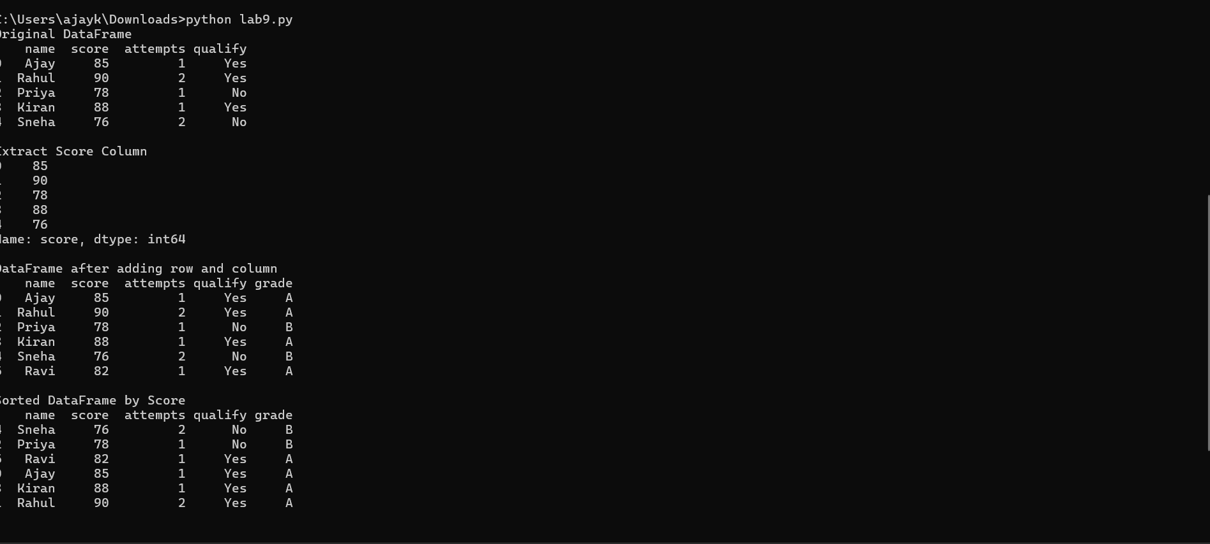

Output
The program displays the original DataFrame, extracted score column, updated DataFrame after adding row and column, and sorted DataFrame based on score. Take screenshots of the output after executing the program.

